TITLE: COMPARATIVE ANALYSIS OF AIR POLLUTION PATTERNS ACROSS INDIAN STATES

TEAM DETAILS:
DATASET NAME: city_day.csv.
TEAM NUMBER: 10
TEAM MEMBERS NAME:
MOHD SHAFIQUE R B 24BAD074
RESHMA S 24BAD097
SASTHA JEYASRI A 24BAD106
THARUN A 24BAD126
DEPARTMENT: ARTIFICIAL INTELLIGENCE AND DATA SCIENCE

INTRODUCTION
Air pollution is one of the major environmental issues affecting public health and quality of life. The dataset city_day.csv provides daily air quality data, including AQI and pollutant concentrations such as PM2.5, PM10, NO2, SO2, CO, and O3 for multiple cities. However, the raw dataset may contain missing values, abnormal readings, and inconsistent data points, which can reduce the effectiveness of analysis and lead to incorrect conclusions. Therefore, preprocessing is performed to improve data quality and make it ready for further analysis. This report presents the preprocessing steps used in the project, including missing value treatment, outlier removal, and generation of a cleaned dataset. The cleaned data is then used for performing EDA and visualization tasks.

WEEKLY REPORT:
WEEK 1:
DATA HUNTING:
- The dataset was obtained from the Central Pollution Control Board (CPCB), the official authority for monitoring air pollution in India.
- It provides reliable and authentic government data collected from certified air monitoring stations.
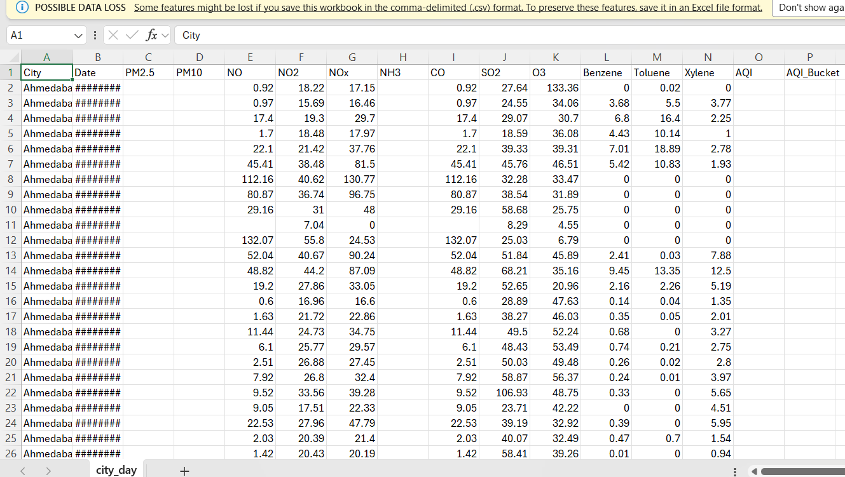
REFERENCE:
- Central Pollution Control Board – Air Quality Data Portal
https://cpcb.nic.in/air-quality-management-portals/
- Central Pollution Control Board – National Air Quality Index (AQI) Information
https://cpcb.nic.in/national-air-quality-index/
- Kaggle – Air Quality Datasets
https://www.kaggle.com/datasets

WEEK 2:
DATASET LOADING:
- Loaded the dataset city_day.csv using the Pandas library.
- Checked the dataset structure and column information.
- Checked shape, column names, and data types.

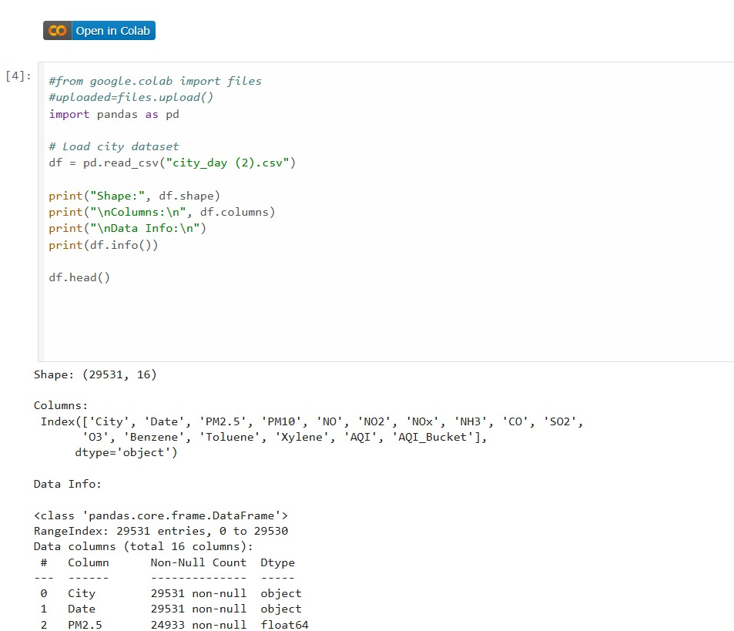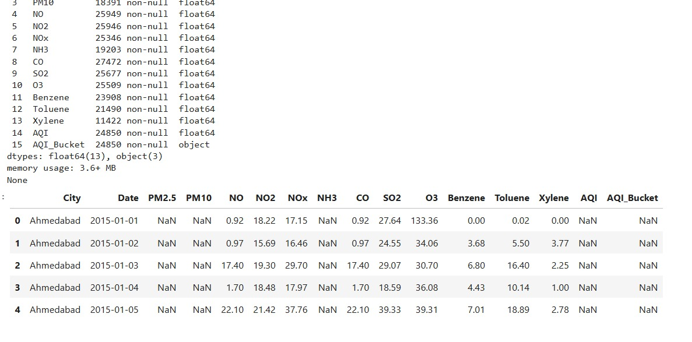
REFERENCE:
Dataset Loading
DATA QUALITY REPORT:
data quality link

WEEK 3:
MISSING VALUE HANDLING:
- Filled missing values in numerical columns using Median.
- Filled missing values in categorical columns using Mode.

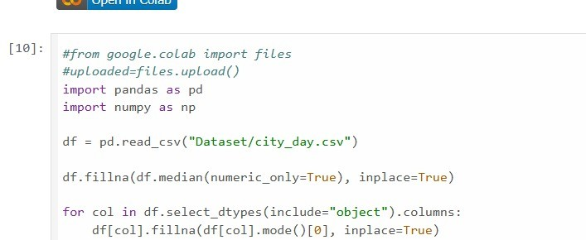
REFERENCE:
missing-data
OUTLIER TREATMENT:
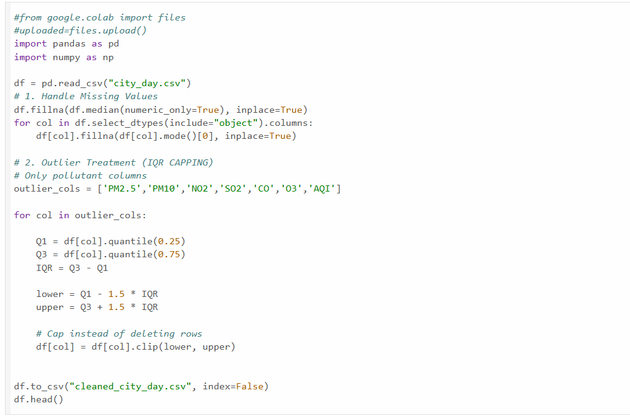
- It is used to find outliers in data.
- Steps:
- $IQR=Q3-Q1$
- Lower limit = $Q1-1.5×IQR$
- Upper limit = $Q3+1.5×IQR$
- Values below the lower limit or above the upper limit are outliers.
- we replace those values with the limits, it is called Winsorization (capping).
- Reduced extreme values that could affect analysis.

REFERENCES:
outlier_handling
CLEANED DATASET:
Dataset/cleaned_city_day.csv
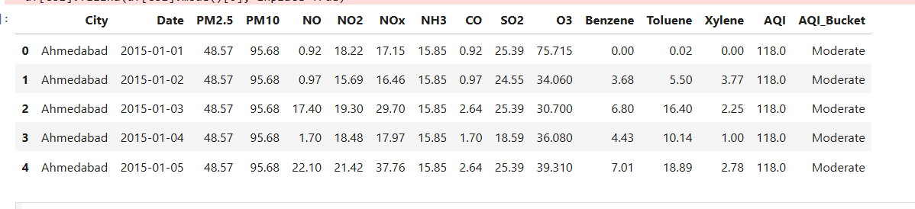
WEEK 4:
Eda statistics:
BEFORE CLEANING:
- Distribution plots revealed skewed patterns and pollution spikes.
- Boxplots identified multiple extreme outliers in pollutant variables.
- Correlation analysis showed strong dependency of AQI on particulate pollutants.

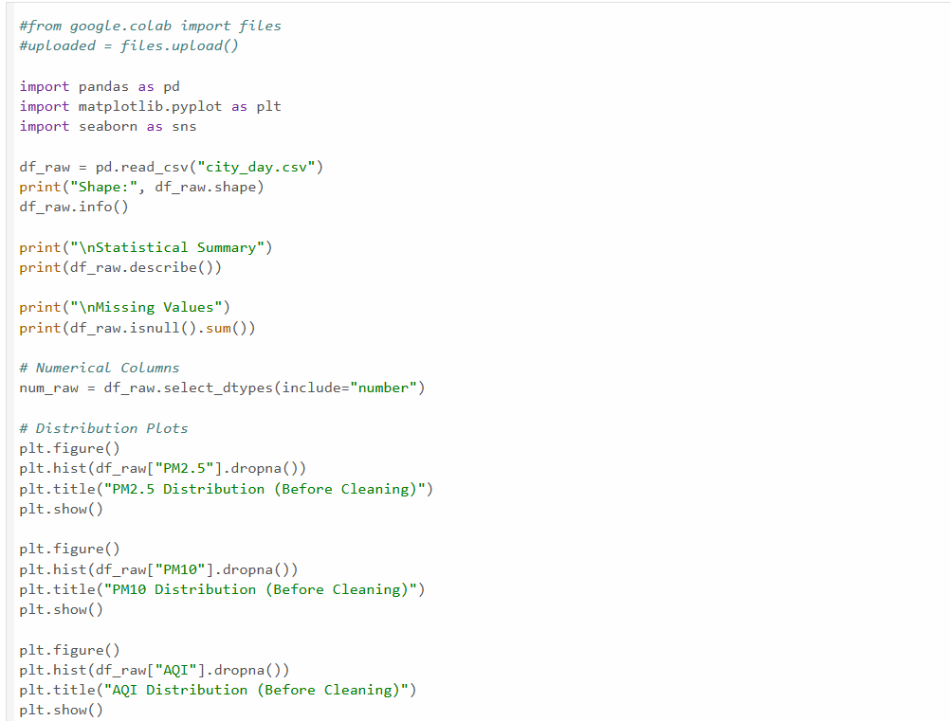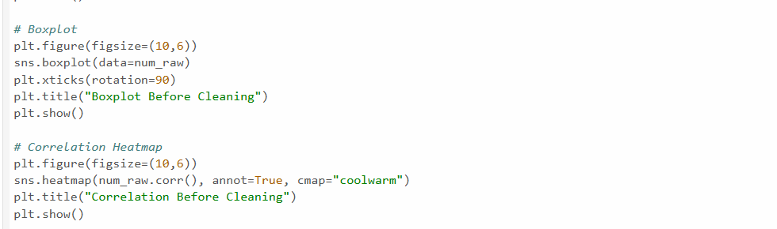
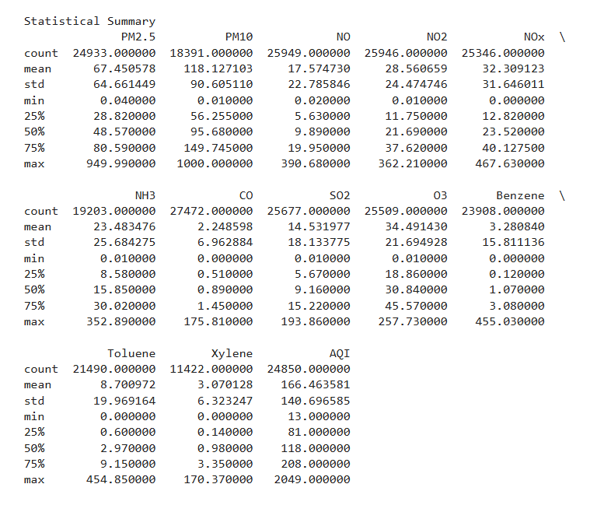
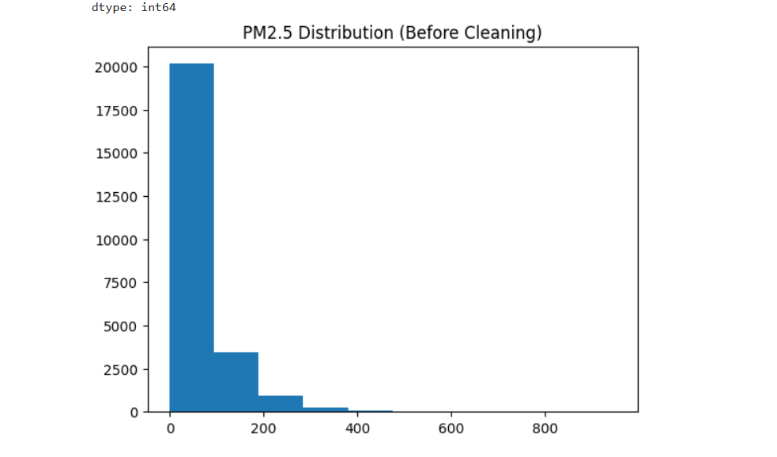
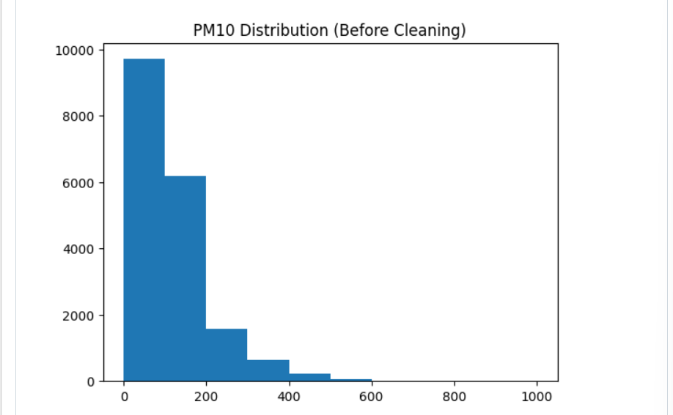
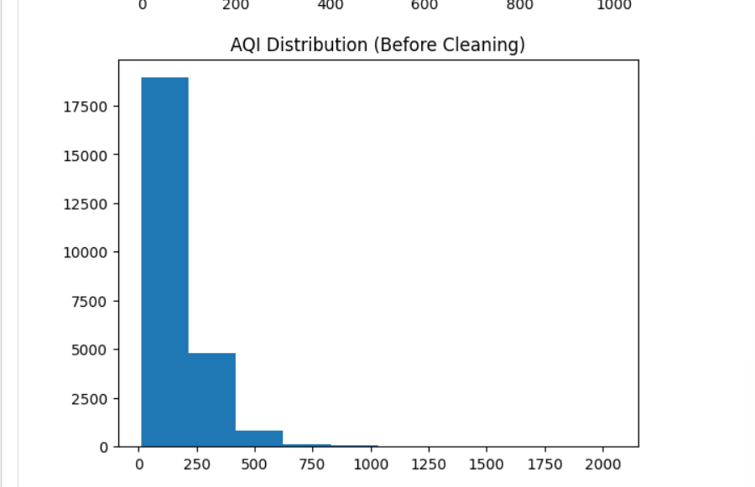
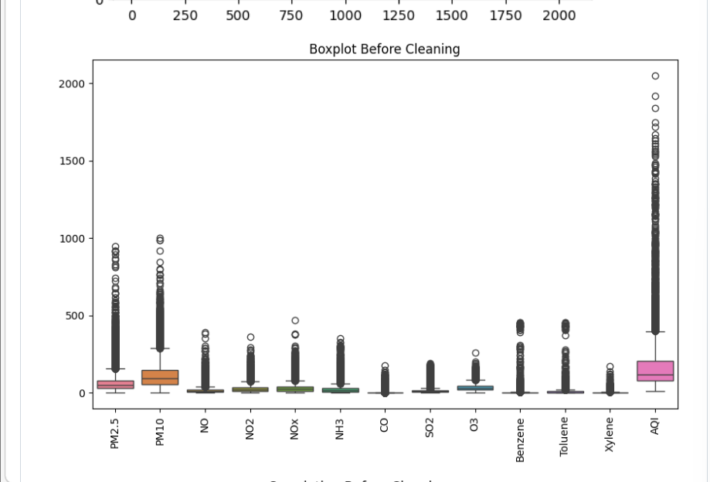
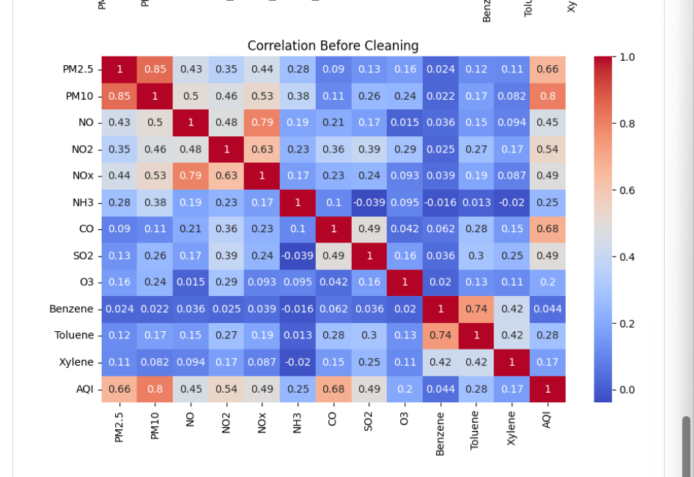

AFTER CLEANING:
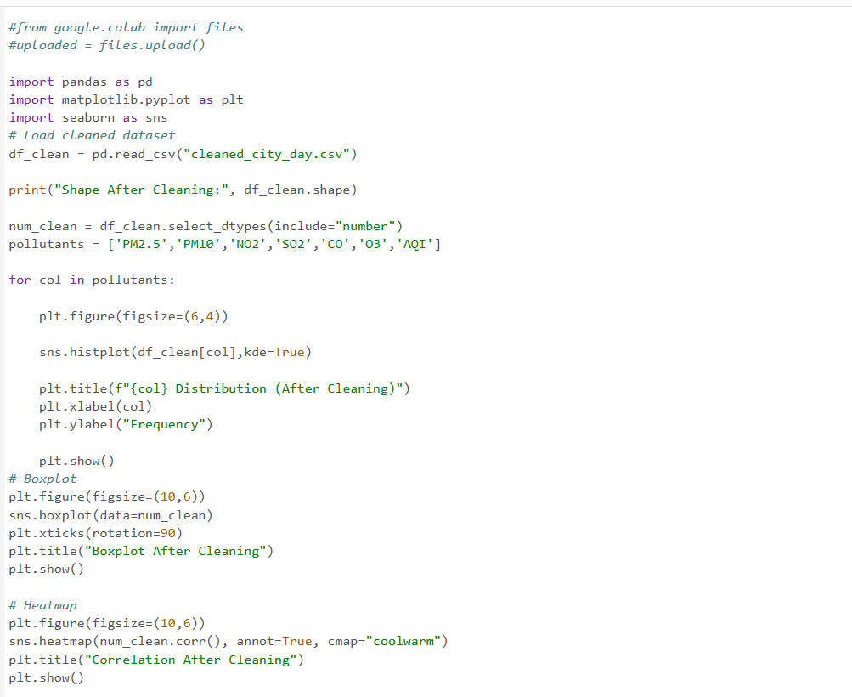
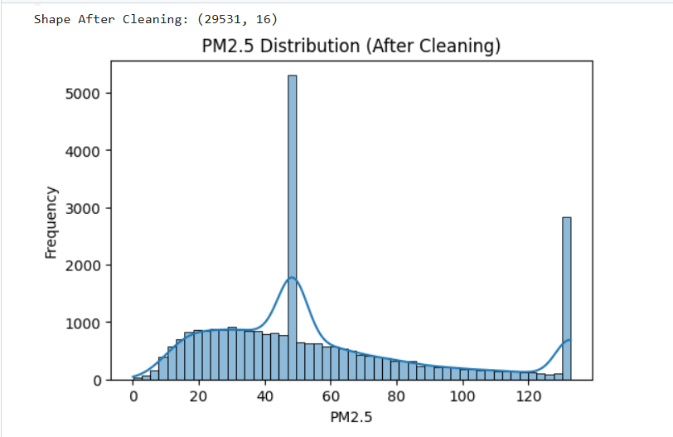
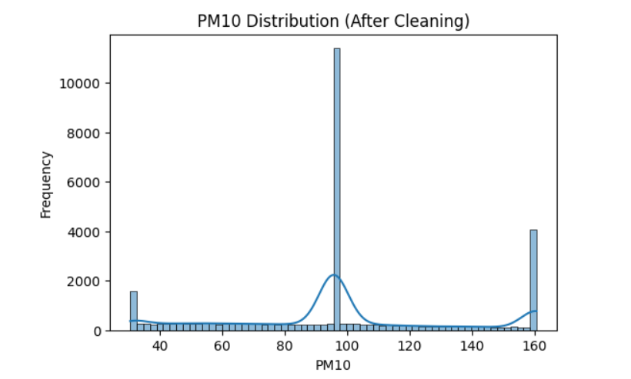
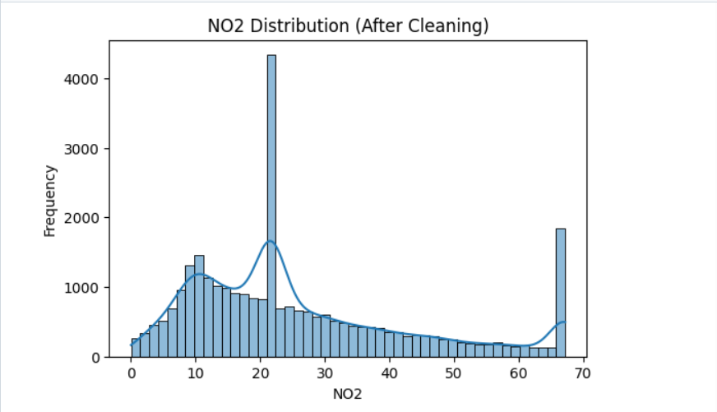
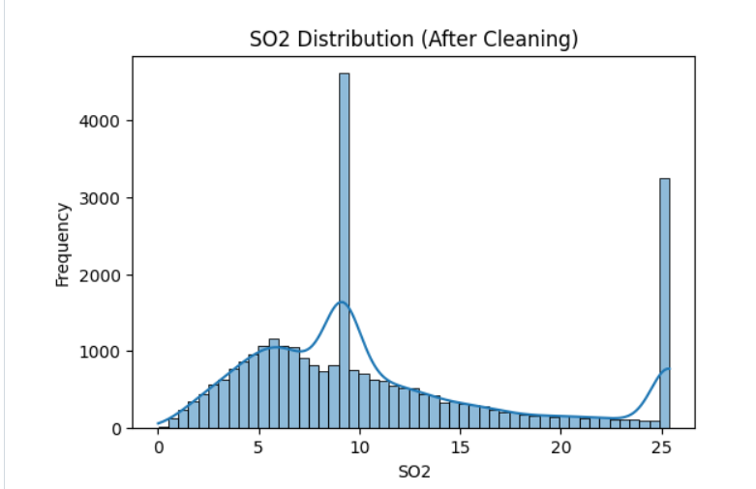

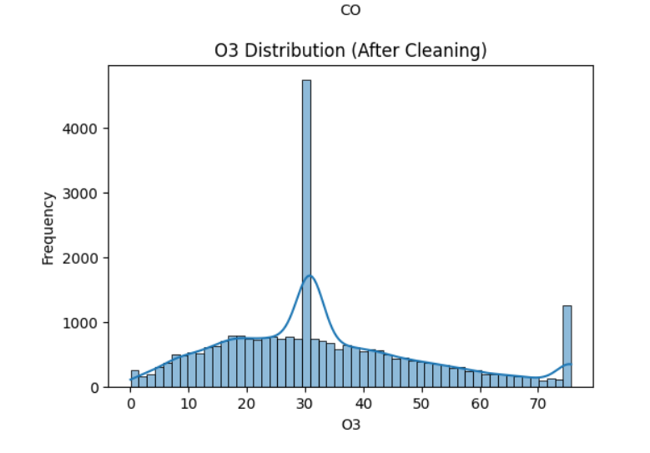
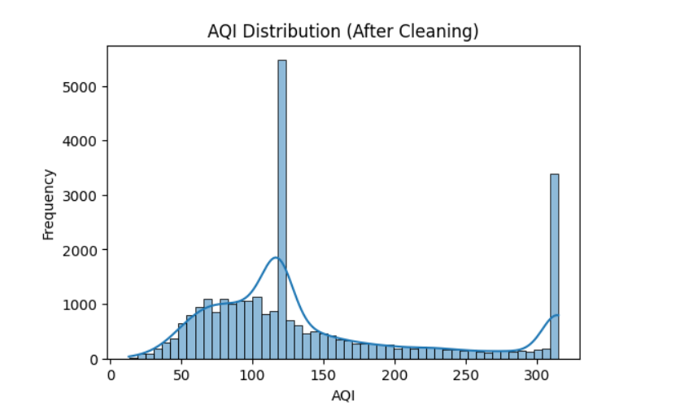
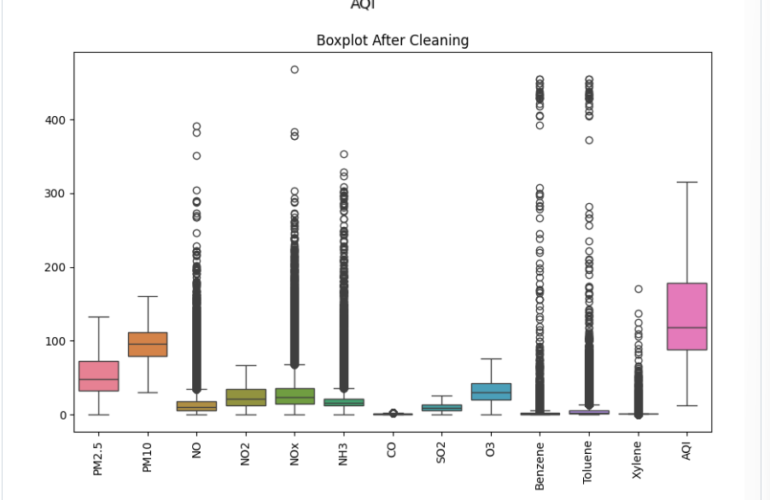
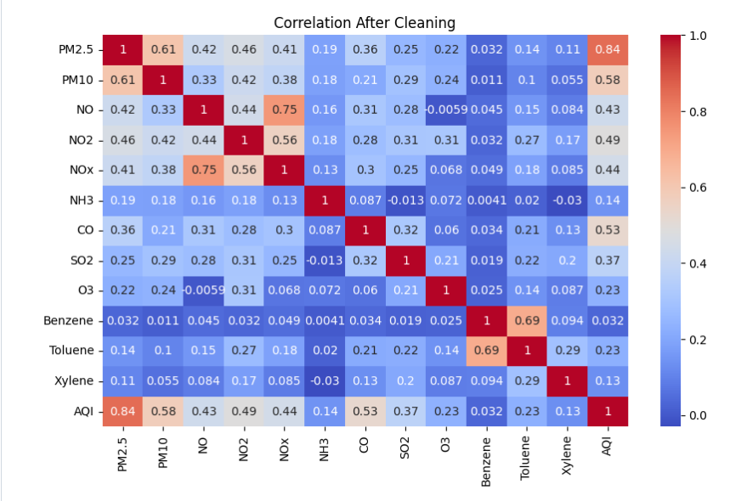
REFERENCE:
exploratory-data-analysis
EDA LINK:
EDA_STATISTICS
WEEK 5:
FEATURE SCALING:
- Feature scaling was applied to standardize numerical pollutant features such as PM2.5, PM10, NO₂, SO₂, CO, and O₃.
- In this project, standardization was used to transform the values so that the features have a similar scale.
- To ensure that all numerical features contribute equally during analysis, scaling techniques were applied.
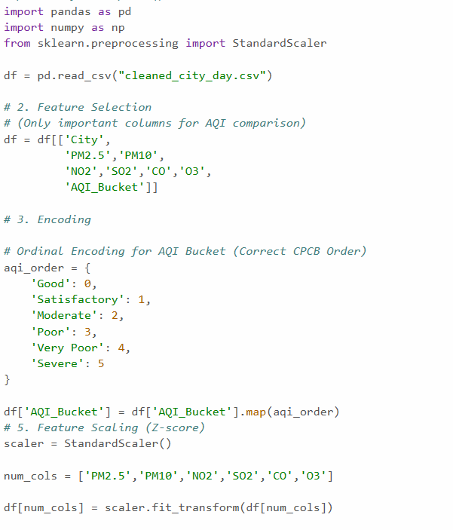

REFERENCE:
Feature_scaling
FEATURE SELECTION:
- In this project, feature selection was performed to identify the most important air pollutant variables influencing air quality.
- Features such as PM2.5, PM10, NO₂, SO₂, CO, and O₃ were analyzed to understand their impact on air quality levels.

REFERENCE:
feature-selection
ENCODING:
- We Encoded the AQI Bucket based on CPCB Order

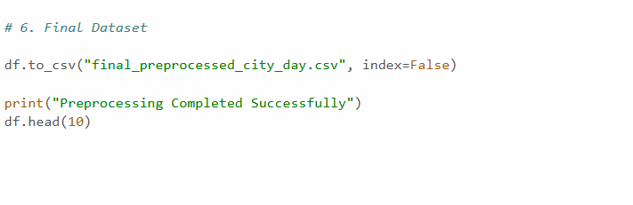
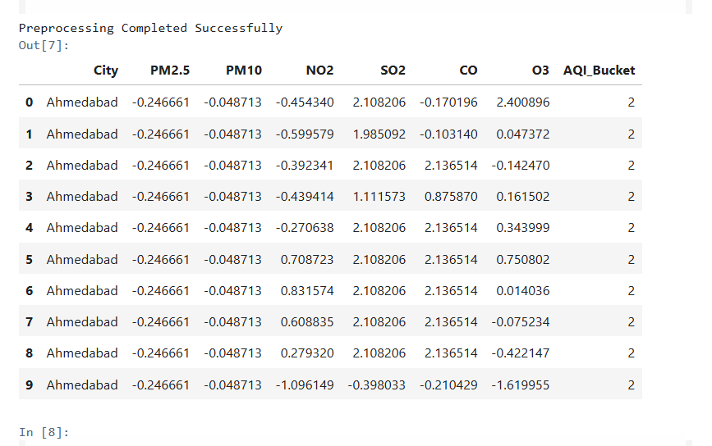
REFERENCE:
Encoding
FEATURE PREPROCESSING LINK:
Feature_Preprocessing
FINAL DATASET:
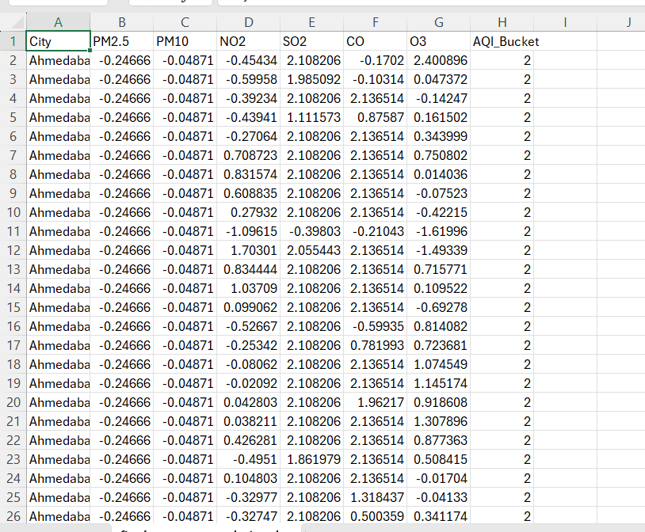
final_preprocessed_city_day.csv
WEEK 6:
PRINCIPLE COMPONENT ANALYSIS:
- Principal Component Analysis (PCA) is a technique used to reduce the number of features while keeping most of the important information.
- It transforms original correlated variables into new uncorrelated variables called principal components (PC1, PC2).
Why PCA is Used Only for Analysis:
- PCA converts pollutant features into PC1 and PC2, which lack direct physical meaning.
- PCA reduces features to only 2 components, making detailed comparison difficult.
- It reduces interpretability for decision-making.
- Therefore, PCA is used only for analysis (patterns & correlations), not for the final dashboard.

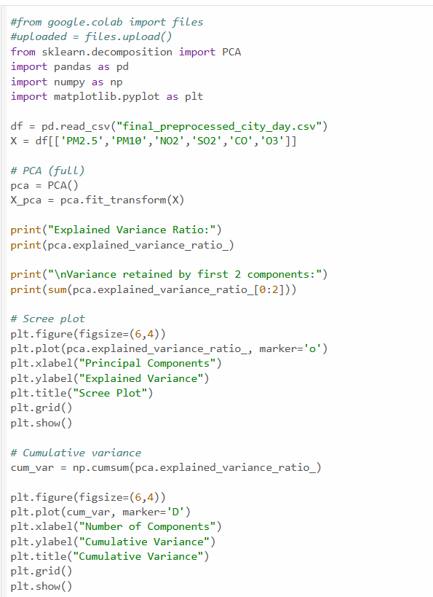
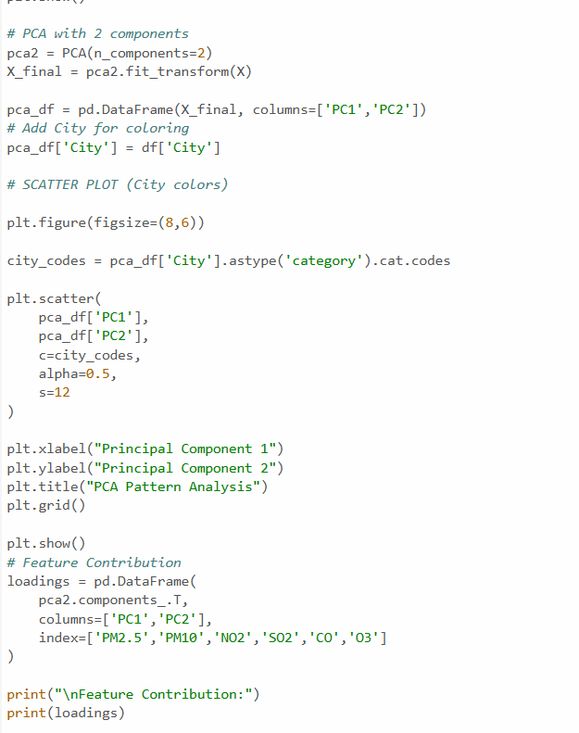
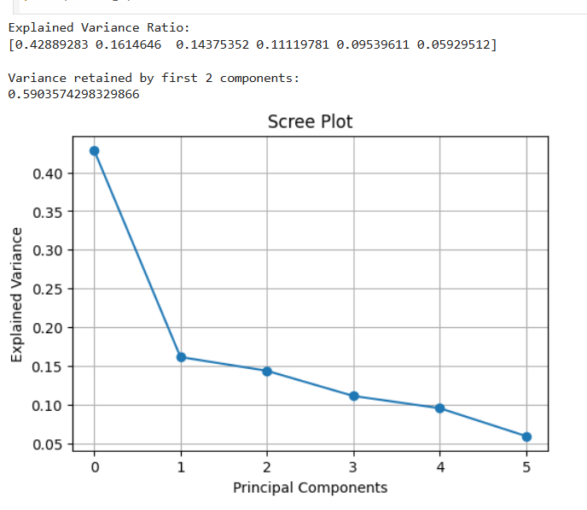
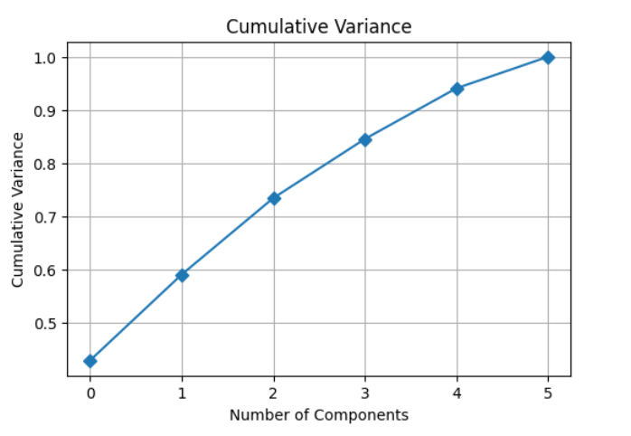
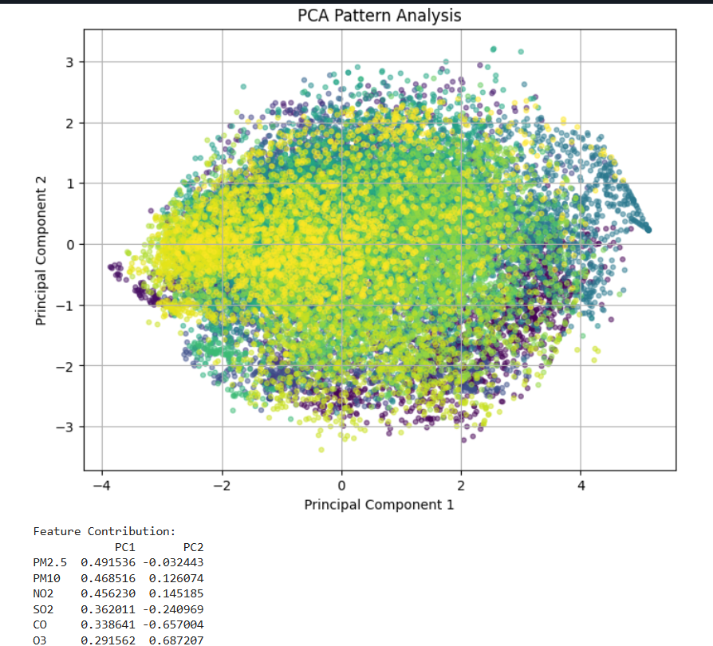

REFERENCE:
principal-component-analysis-pca
PCA LINK:
PCA_Analysis

